

International Commercial Vehicle Show
Crocus Expo IEC, Moscow
September 6-11, 2021

Post Release Media contact:
Valeriya Rybchak
September 24, 2021 Email: valeriya.rybchak@itemf.ru

The 16th edition of the largest commercial vehicle event in Russia and Eastern Europe has been held on 7-11th September 2021 at Crocus Expo in Moscow. This year COMTRANS featured 141 exhibitors from 9 countries. Major OEMs presented the newest trucks, LCVs, buses, trailers, and special utility vehicles. Alternative fuels for commercial vehicles, including electric power, hydrogen, and natural gas became the hot topic of the trade show.

The event has been kicked off by the winner ceremony of ‘Za rulem’ Grand Prix for commercial vehicles, mastered by the chief editors of two leading Russian automotive media – Za rulem and Reis magazines. 35 models launched in the Russian market from 1st June 2020 till 30th April 2021 have been nominated in 7 categories of vehicles, and the jury included 35 top managers and professionals of visible Russian fleet owners/operators.
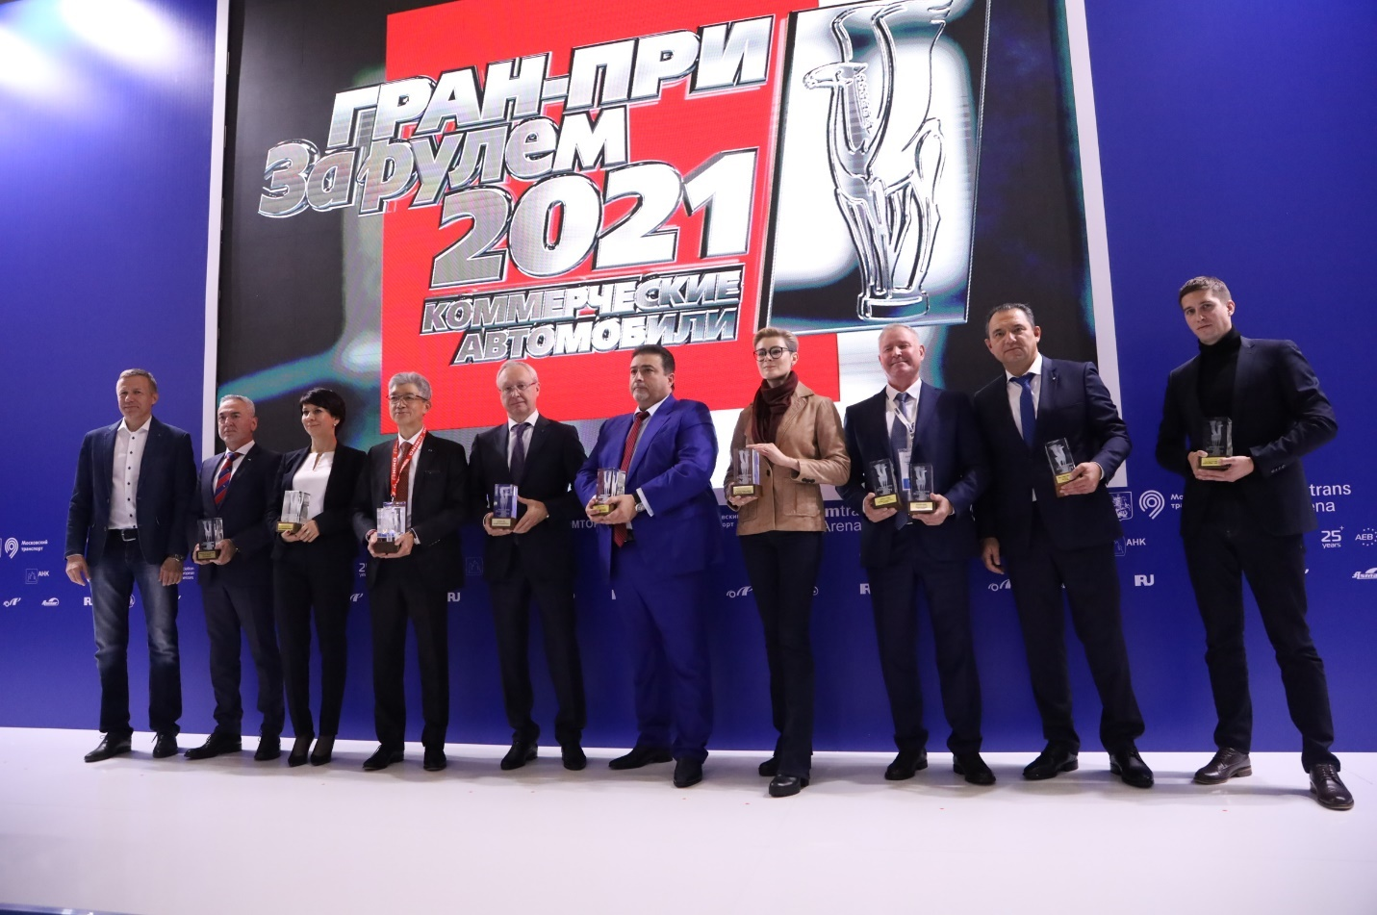
The winners of the 2021 ‘Za rulem’ Grand Prix:
- LCV – GAZel NN
- Midsize trucks – Hino 300 XZU720
- Heavy trucks – Mercedes-Benz Actros
- Construction trucks – KAMAZ-6595
- Small/midsize buses – Ford Transit
- Large buses – KAMAZ-6292
- Trailers – Schmitz Cargobull S.KO COOL SMART

The Grand Prix ceremony has been supported by leading Russian tire producer Cordiant and Turkish Automotive Exporters’ Association OIB.

The official opening of COMTRANS which has been held after the Grand Prix featured welcome speeches from high-ranked VIP guests of the event.
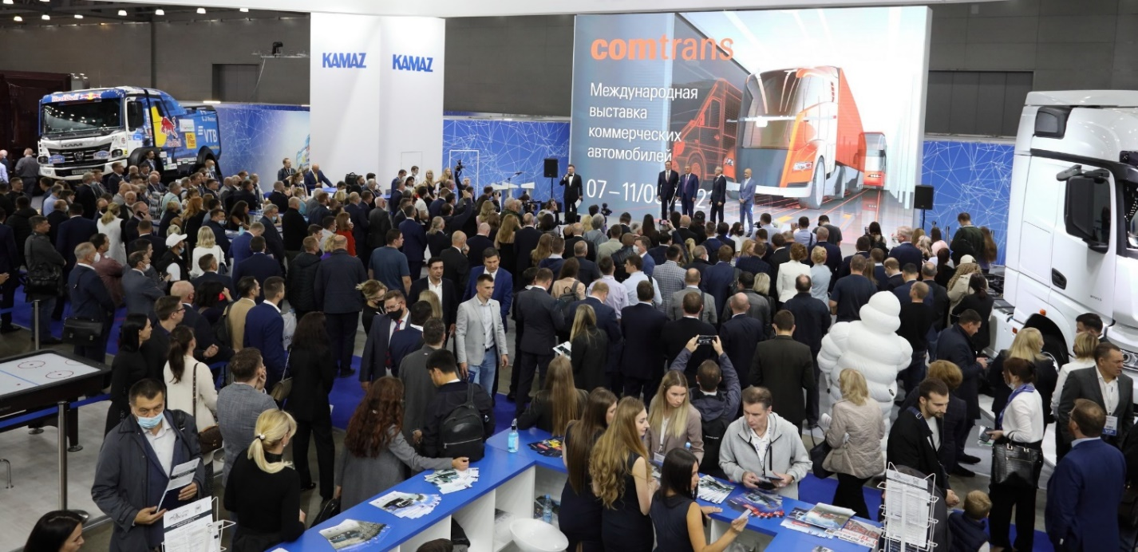

Russian Vice Premier Yury Borisov: “Automotive industry is one of the most important branches of Russian economy. Every single job in the automotive sector generates 8 jobs in other ones. This is a very important effect, so our government gives a lot of attention to growing competences in Russian automotive, and this exhibition shows that we can be proud of it. Here we see not the prototypes, but production models of commercial vehicles moved by electric and hydrogen-based power, real implementation of global trends towards the green economy.”
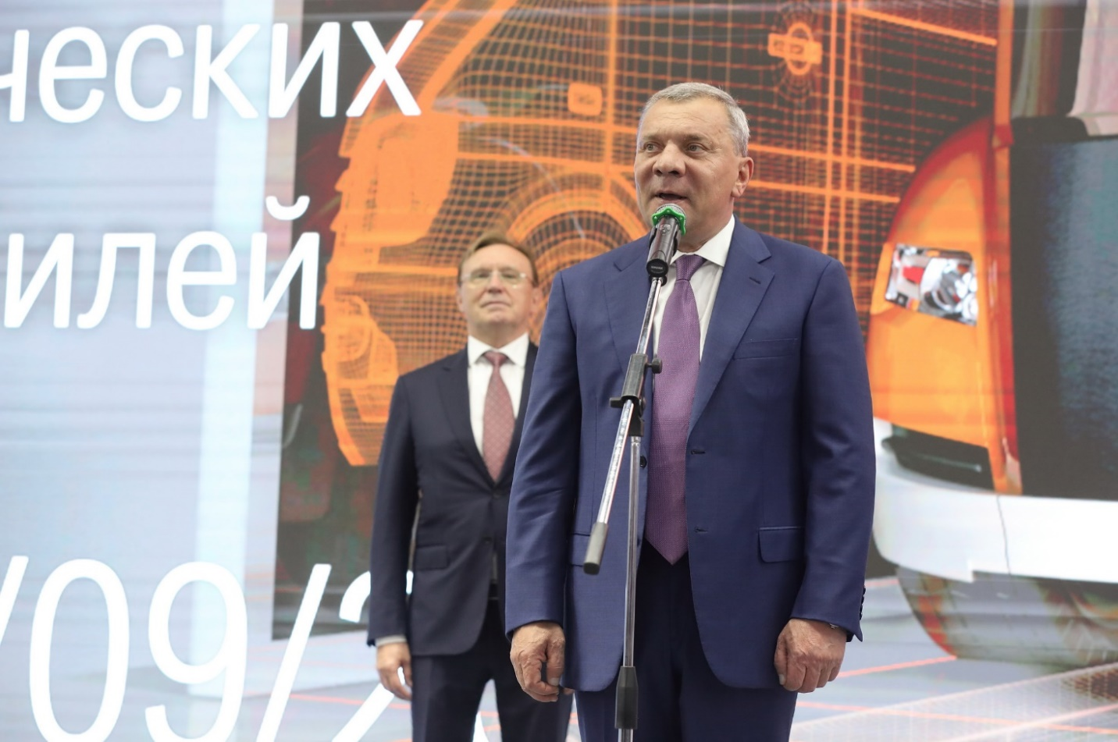

The CEO of KAMAZ Sergey Kogogin: “Having visited the stands at this exhibition, I am proud that our automotive industry has moved up closer to the highest global standards. I believe we have a great potential based on mutual understanding with the Russian government and the size of the Russian market.”
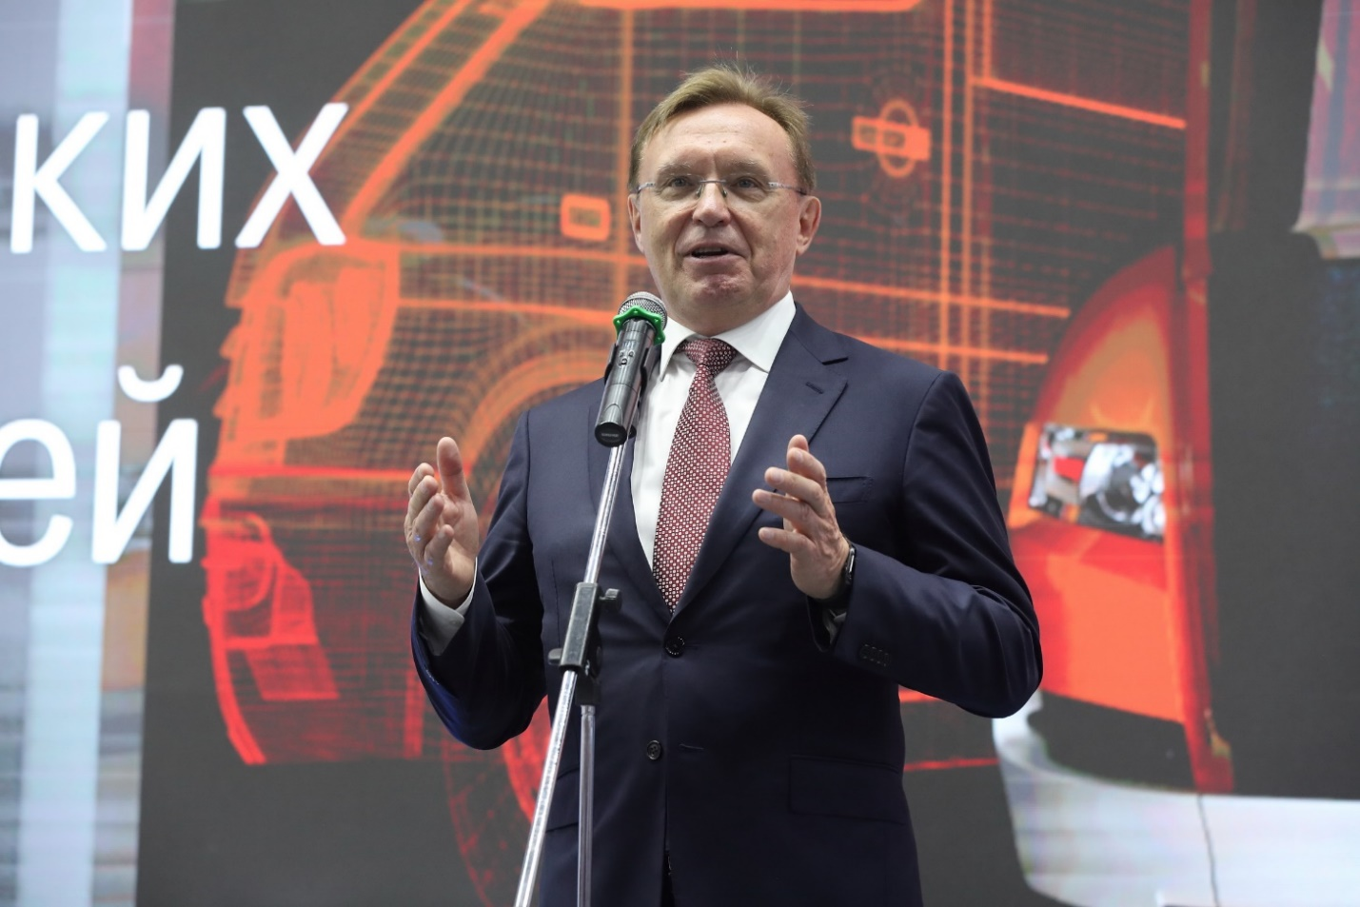

The President and CEO of GAZ Group Vadim Sorokin: “Every exhibitor at this event has something to be proud of to present, however, the most important is that our clients have come to us. I am absolutely convinced this exhibition will help us in defining our strategic directions and help Russian transport and logistics companies to define their ways of development.”
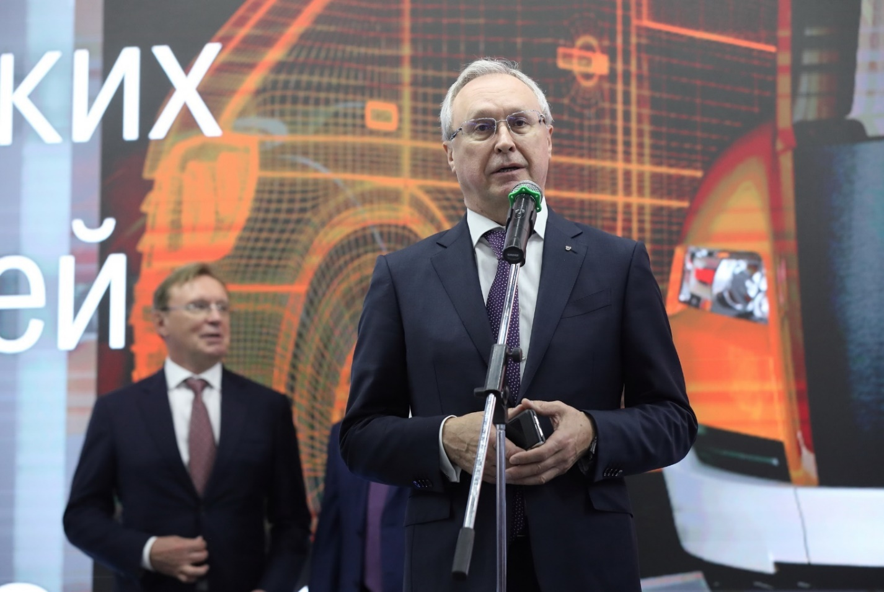

The CEO of Association of European Businesses Tadzio Schilling: “COMTRANS is the key event for both commercial and technological development of the automotive industry. Having visited the exhibitors’ stands, I am happy to state that local and international companies present the most innovative products and solutions for the development of sustainable transport in Russia.”
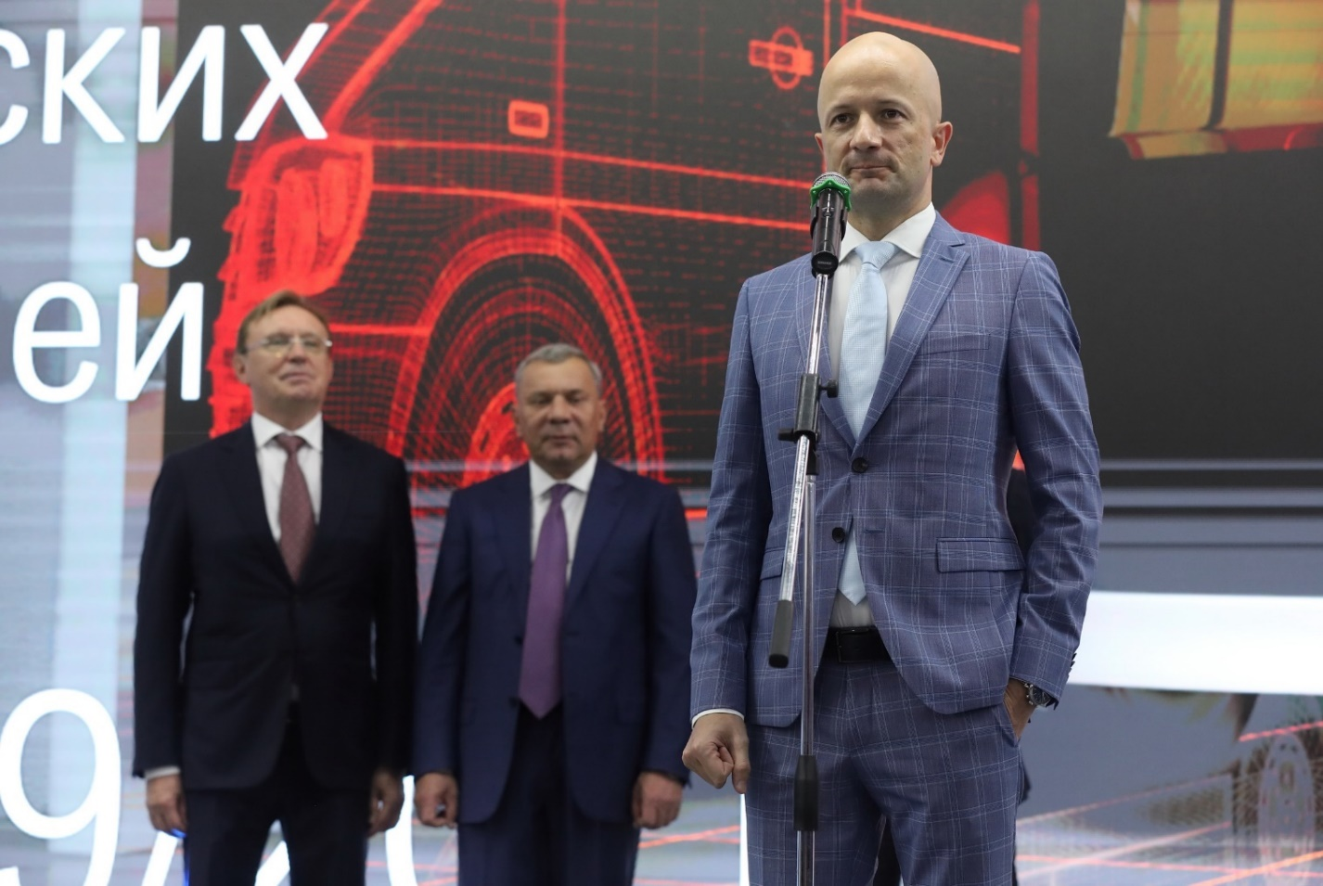

Denis Manturov, Russian Minister of Industry and Trade has visited COMRANS 2021 on the second day of the exhibition. He has spent half a day at the show visiting major exhibitors’ stands, giving his most attention to hydrogen-powered bus KAMAZ-6290, GAZ Group’s buses CITYMAX Hydrogen and GAZelle City Hydrogen. He also liked a new articulated electric bus by PKTS, and the high quality of products presented at the stand of MAZ Group where he was hosted by the Belorussian Ambassador to Russia. The Minister has also visited stands of ISUZU, URAL, ZF, Knorr-Bremse, Bosch, and Itelma.
“COMTRANS is a great opportunity for the OEMs to present their products to customers and partners, - said the Minister – Vehicles with a low carbon footprint are one of the priorities of Russian industrial strategy. I am happy to see the hydrogen power-based novelties at the exhibition – the buses by KAMAZ and GAZ Group.” He has also stated that starting 2023, hydrogen-based vehicles will be covered by national subsidies for commercial lease.
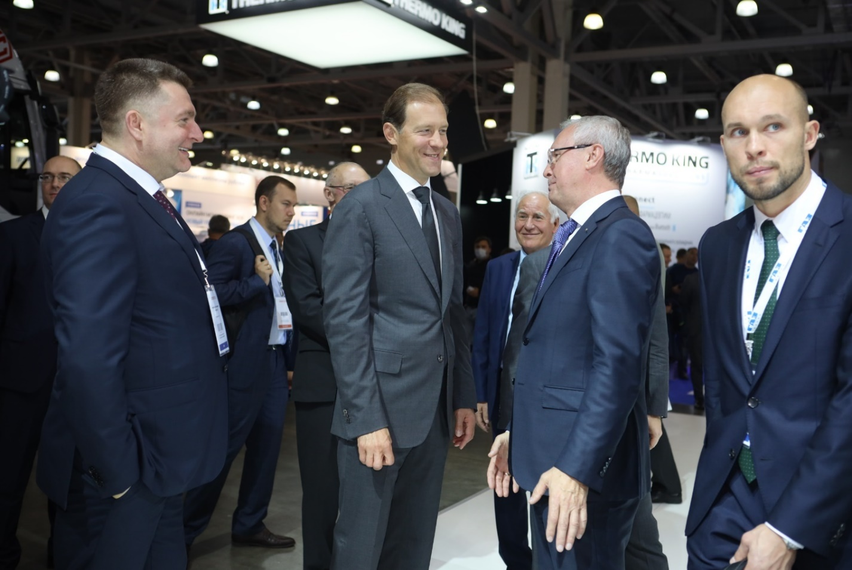

Maksim Liksutov, the Head of the Moscow City Transport, has visited COMRANS 2021 on its third day. Together with KAMAZ’s Sergey Kogogin and Rosnano’s Chairman Sergey Kulikov he has signed a trilateral action plan for local production of hydrogen fuel cells and hydrogen-powered buses.
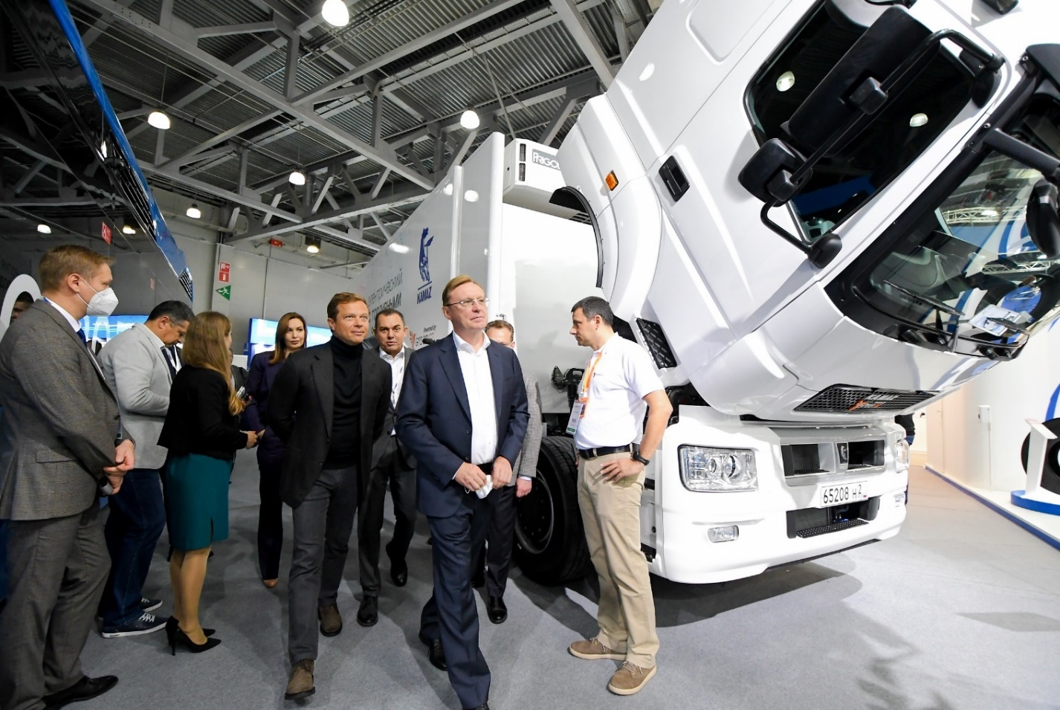

Premieres by OEMs exhibiting at COMTRANS 2021

KAMAZ presented a lineup of K5 generation of dump trucks, including KAMAZ-65951 (8х4), KAMAZ -65959 (6х6) and KAMAZ -65953 (8х8), CNG-based bus NEFAZ-5299-31-57, hydrogen-powered bus KAMAZ-6290, articulated electric bus KAMAZ-6292, trolleybus KAMAZ-62825, electric garbage truck KAMAZ-53198, and a new midsize truck - the Compass 9. The outdoor exposition featured CNG-based tractor KAMAZ-5490 coupled with a new semi-trailer NEFAZ-93348, concrete mixer 58146W, haul trucks KAMAZ-65807 (The Atlas) and KAMAZ-6561 (The Hercules), a number of special vehicles produced with KAMAZ partners. The Continent – KAMAZ’s K6 generation prototype, fully digitized and with solar power-based semi-trailer became the showstopper for all 5 days of the event.
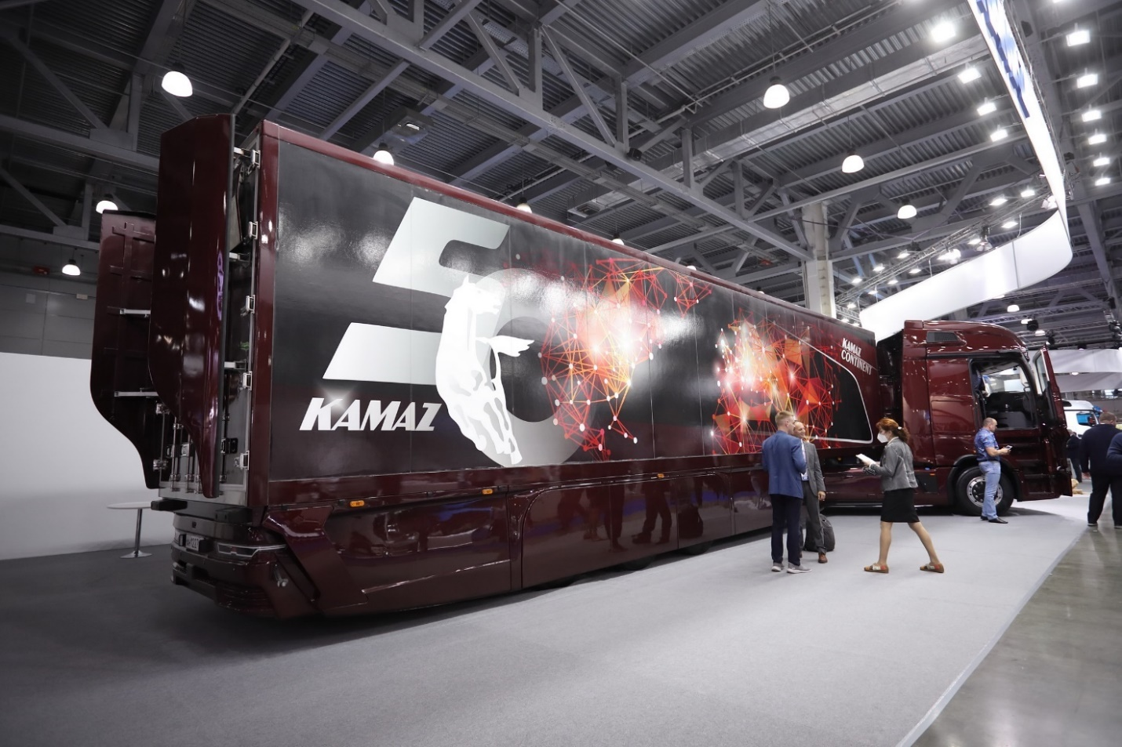

GAZ Group presented 15 vehicles featuring more than 100 engineering innovations – electric and hydrogen-power vehicles, new digital services, comfortable buses for disabled passengers, anti-Covid air filtration systems, new truck models with automatic transmission and ADAS.
The GAZ Group’s President and CEO Vadim Sorokin has personally presented two new hydrogen-powered vehicles – large size bus CITYMAX and GAZelle City e-NN. The Group’s other novelties included midsize Euro-6 CITYMAX 9 and electric E-CITYMAX 12.
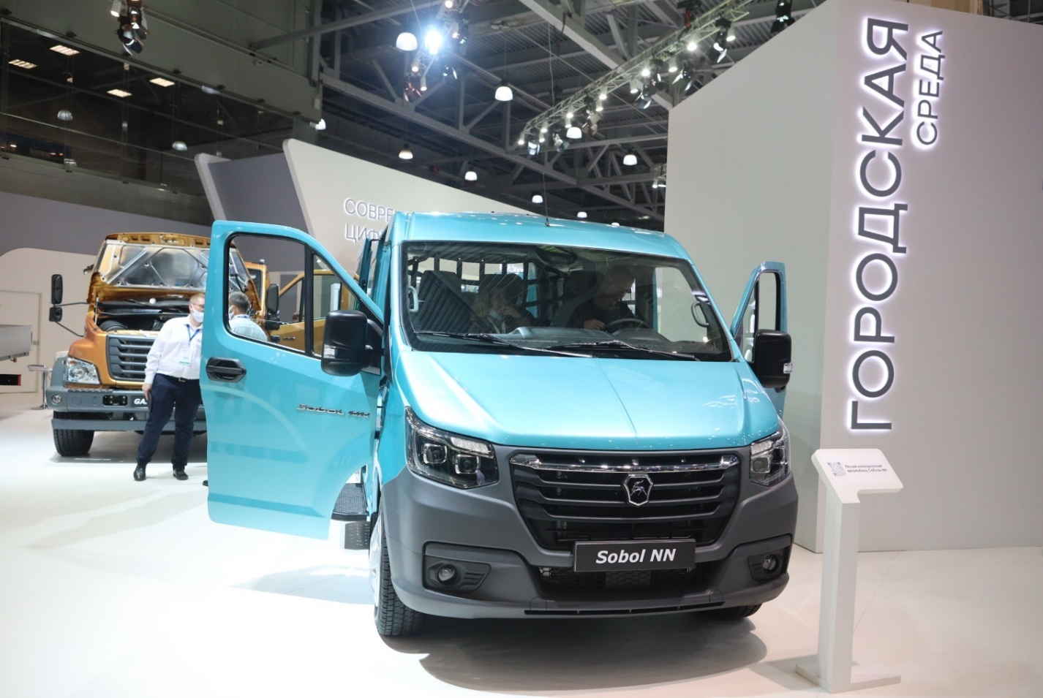

MAZ Group presented new tractors, dump trucks and electric buses; a powerful racing truck just returned from the Silk Road race with a silver medal became a real showstopper at their stand. The exhibited novelties included tractor MAZ-54402N with Weichai Power WP13NG430E2 engine, dump semi-trailer MAZ-95300, Euro-5 6x2 tractor MAZ-6410XX, 6x7 dump truck MAZ-651428, 6x6 chassis MAZ-6302С5 with Soosan SCS746L crane, the third-generation electric bus MAZ-303Е10.
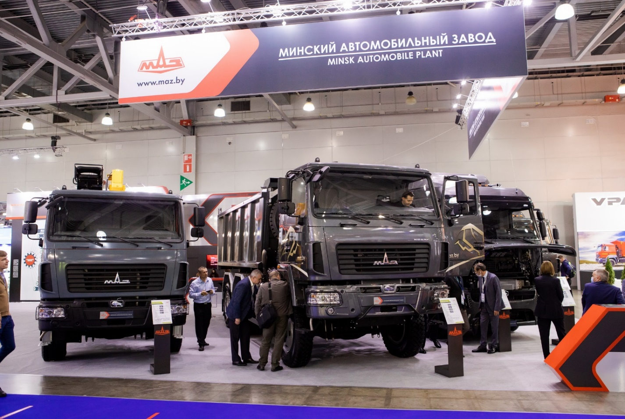

ISUZU, together with their partners from Arctic Trucks, presented a new advanced model of their best-selling truck ISUZU D-Max AT35 2021. Their stand has been also featured with a new midsize 4x4 ISUZU ELF 8.0, new 3-axle dump truck ISUZU GIGA 6×4 produced in partnership with TFK Feniks, upgraded 3-axle chassis ISUZU FVR 21T, new long version of intercity bus produced together with SIMAZ automotive plant.
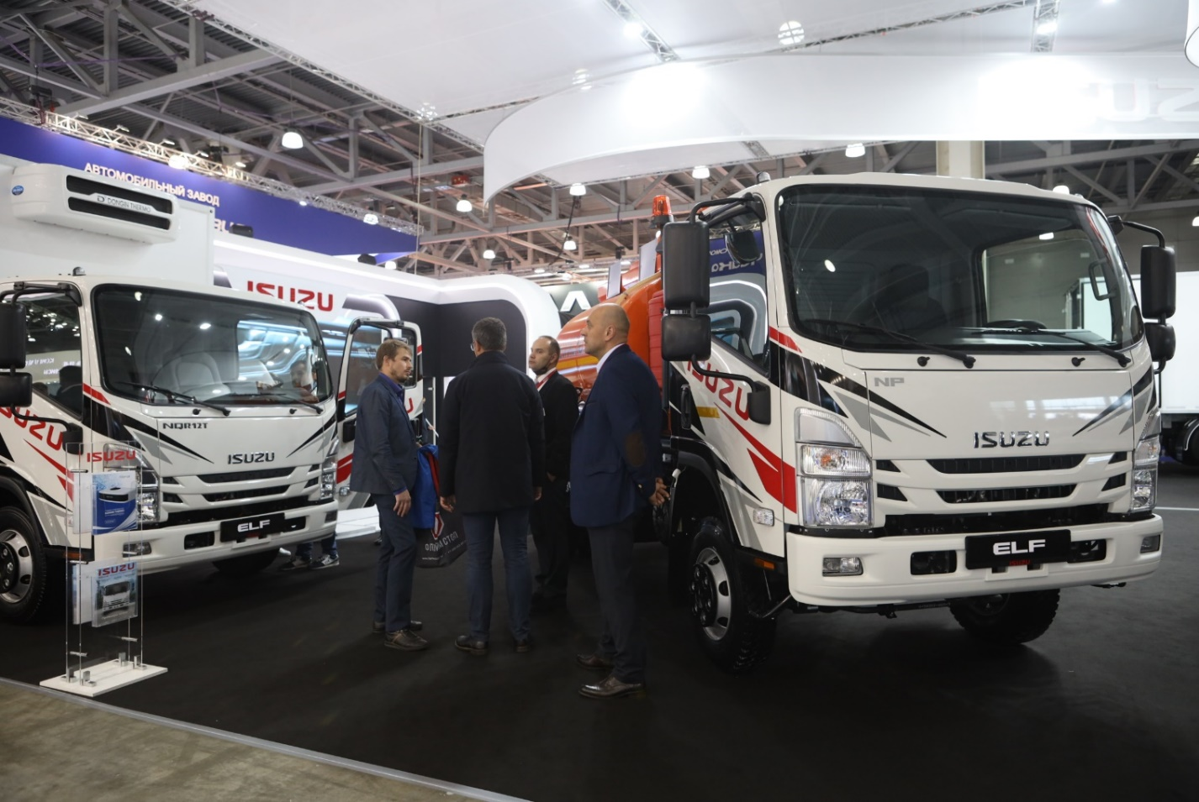

URAL showed four new trucks of their cab-over family, including 6х4 flagship URAL C35510 with load capacity of 21.5 tons, dump truck URAL C34520 with load capacity of 16 tons, mid-haul tractor URAL C35410, and a new garbage truck produced in partnership with Merkator Group.
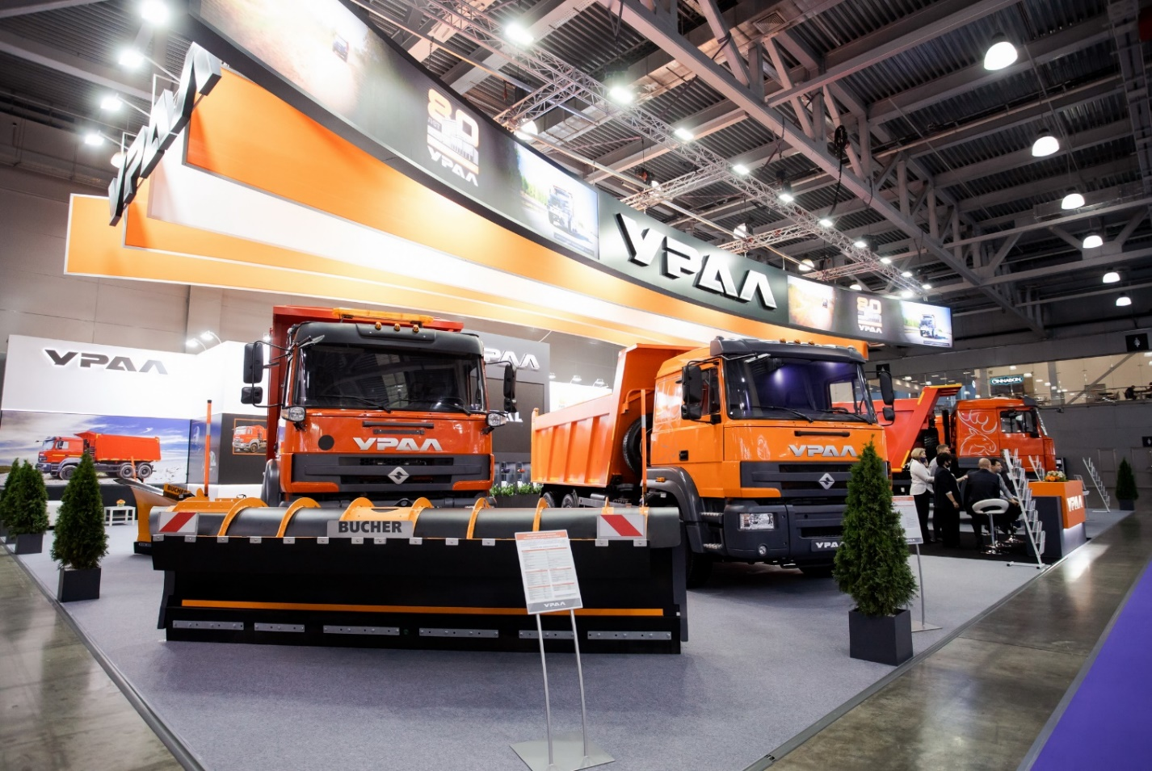

Under the ‘100% CONNECTED’ motto, German Schmitz Cargobull presented a modern and innovative isothermal semi-trailer S.KO COOL SMART EXECUTIVE powered with S.CU cooling engine and digital temperature recorder.
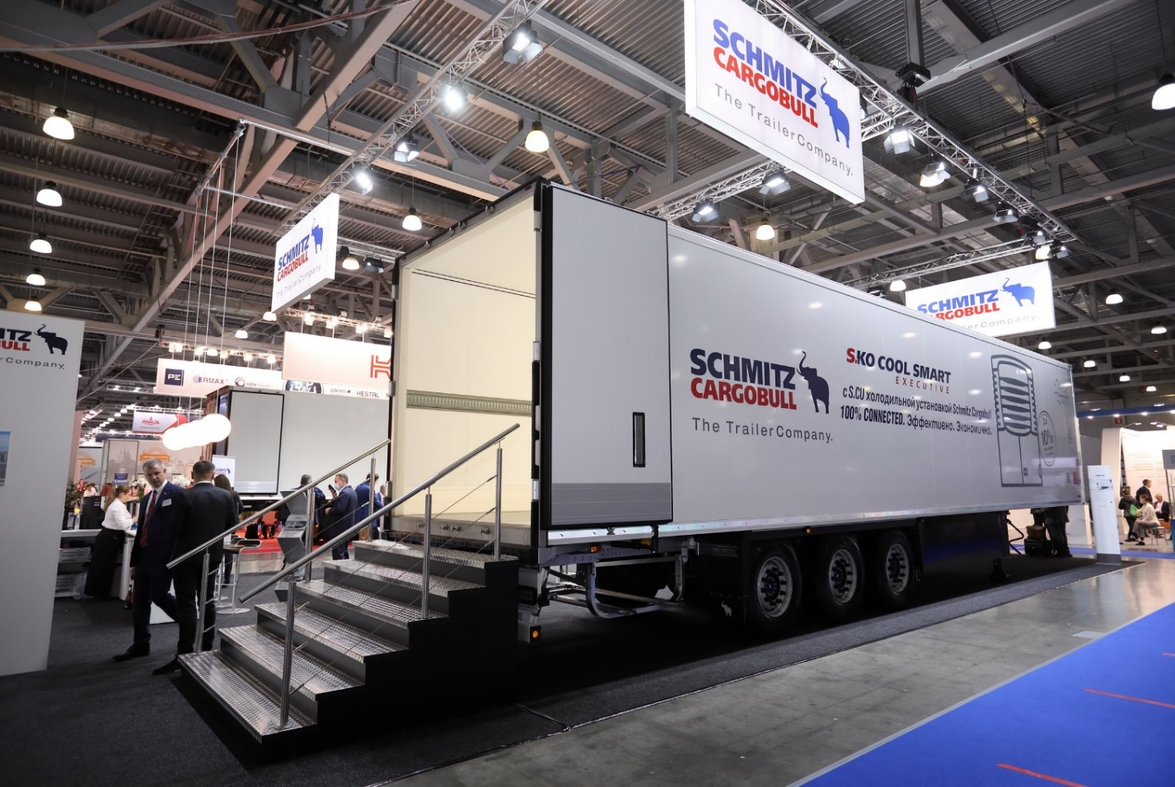

Business programme at COMTRANS Arena

The issues of sustainability and ecological safety are driving factors for the OEMs' development towards the use of alternative power for commercial vehicles. The content at COMTRANS exhibitor stands showed that the industry is really moving to natural gas and electric/hydrogen platforms.
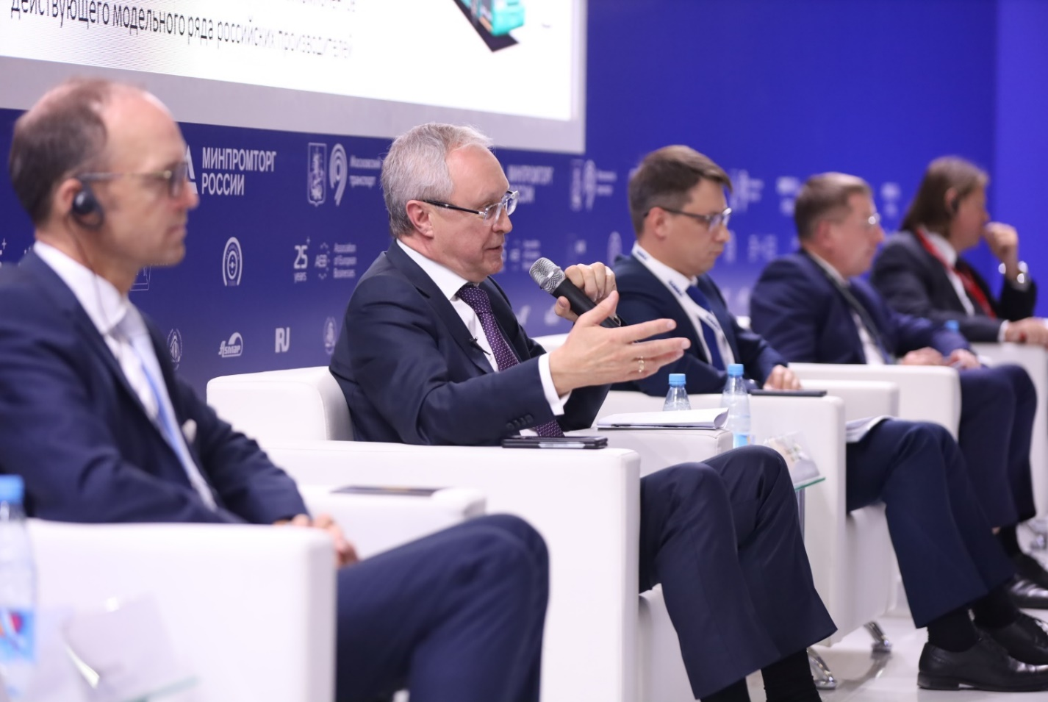
Those and related topics became a base for a reach conference program at COMTRANS Arena during all 4 business days of the exhibition. More than 70 speakers – professionals from automotive and transport industries included OEM CEOs, representatives of Euro-Asian Economic Commission, Ministry of Industry and Trade, Ministry of Transport, Rosenergo, Moscow City Transport Department, other national and international regulators, industry associations, market analysts, fleet managers, and digital solution providers. 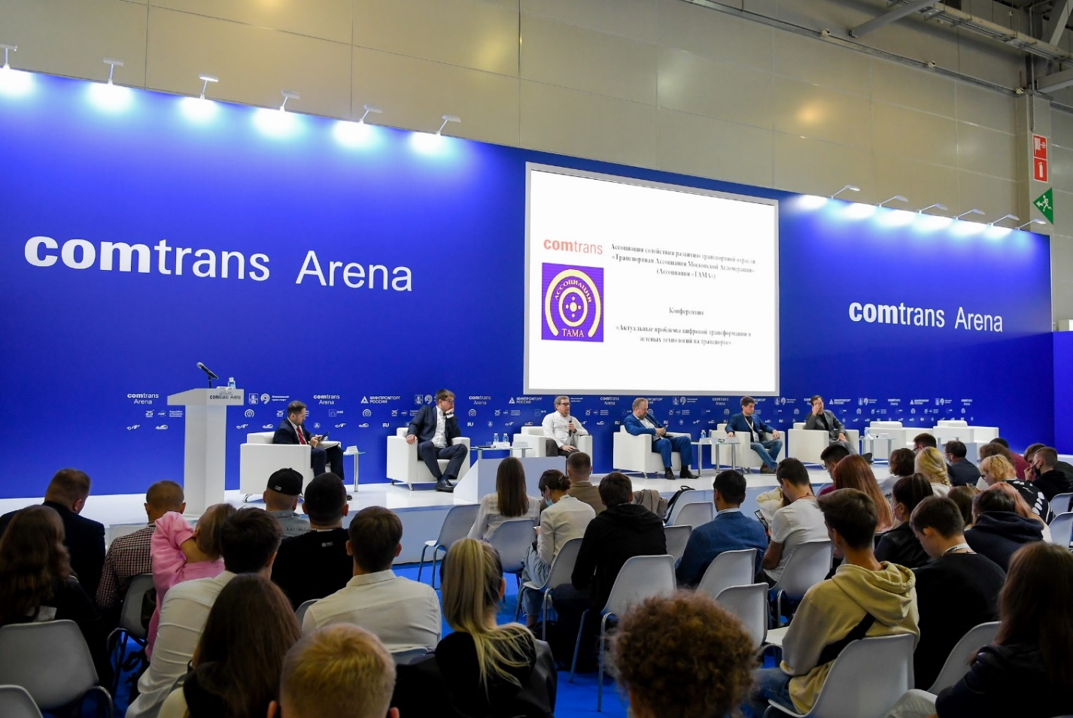

The program has been attended by 600+ visitors from commercial fleet operators, dealers, service providers, professional drivers, and media.
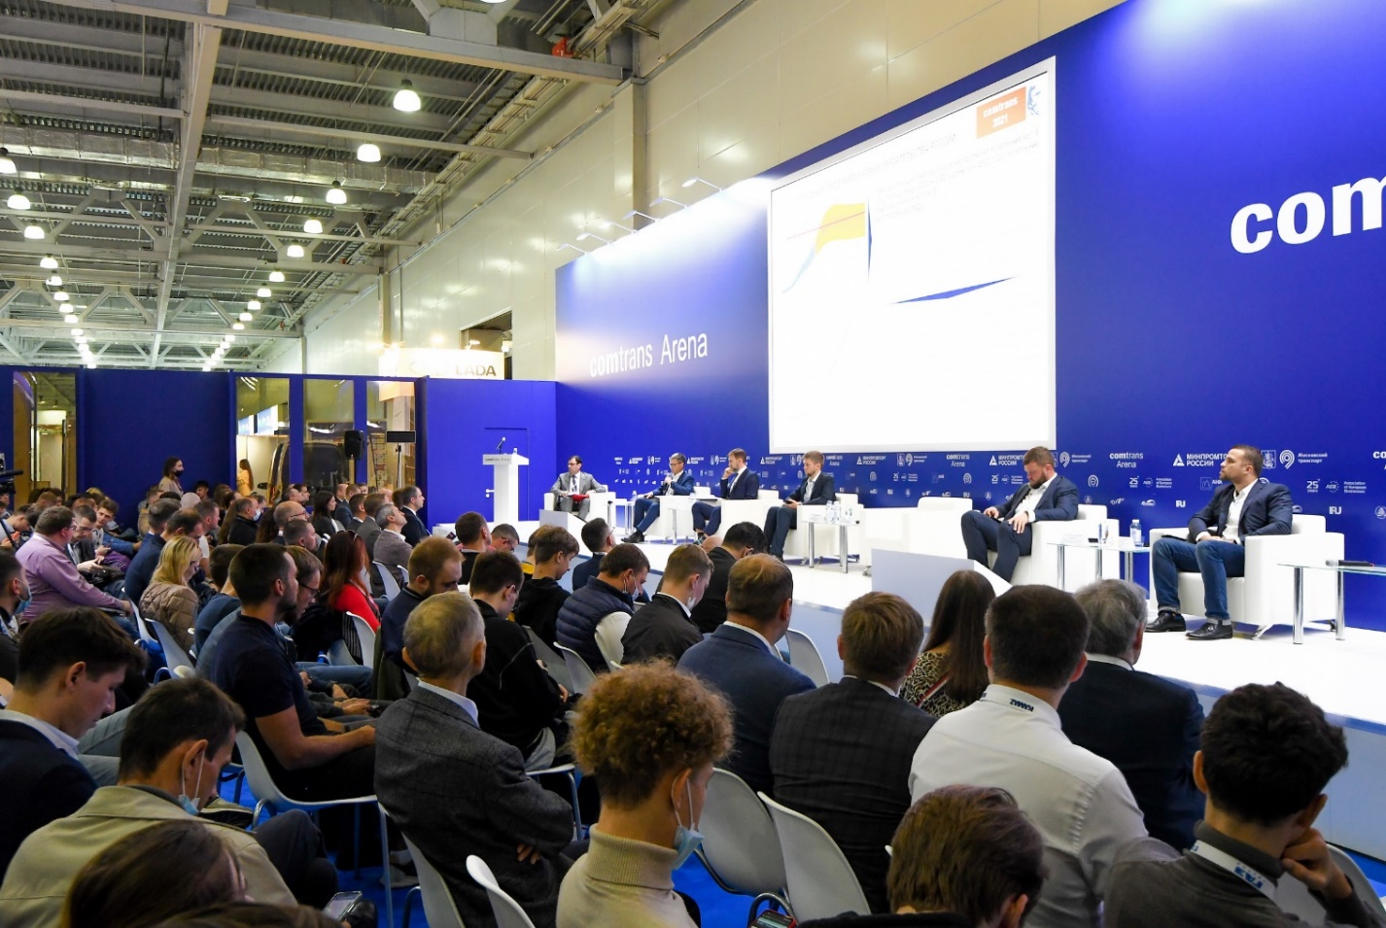

The partners for organizing the panel discussions at COMTRANS Arena included the Association of European Businesses, German Trade Chamber AHK, the TAMA Association, IRU, International Road Hauler Association ASMAP, National Gas Vehicle Association NGA, German Association VDA, the Autostat Analytic Agency, and many others.

